Свято англійської мови
з використанням
мультимедійних засобів у 4 класі
The princess and the pea

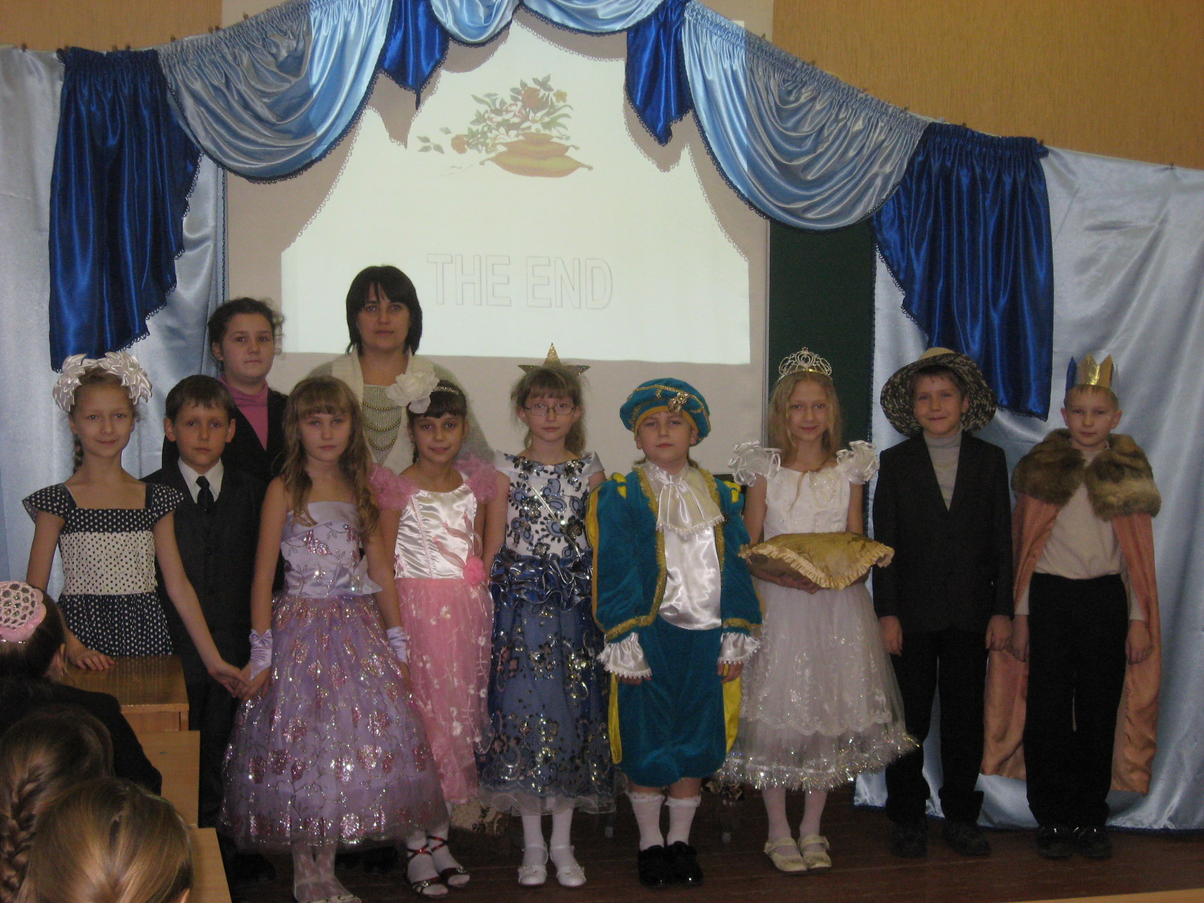

Підготувала вчитель англійської мови
Підопригора Ю.В.

2011-2012 н.р.

The princess and the pea
Цілі:
практична: розвивати вміння усного мовлення;
формувати здатність перевтілюватись у казкових героїв та вміння створювати декорації з використанням мультимедійних технологій;
освітня: поглибити знання учнів про художні засоби мови та можливості використання програмних засобів Microsoft Office;
розвивальна: розвивати гнучкість артикуляційного апарату, творчу уяву, образність мислення, здатність мовного самоконтролю;
виховна: виховувати в учнів інтерес до англійської мови та основ комп’ютерної грамотності; сформувати почуття задоволення за набуті знання, усвідомлення своєї успішності.

The princess and the pea
(The stage is decorated as a castle)
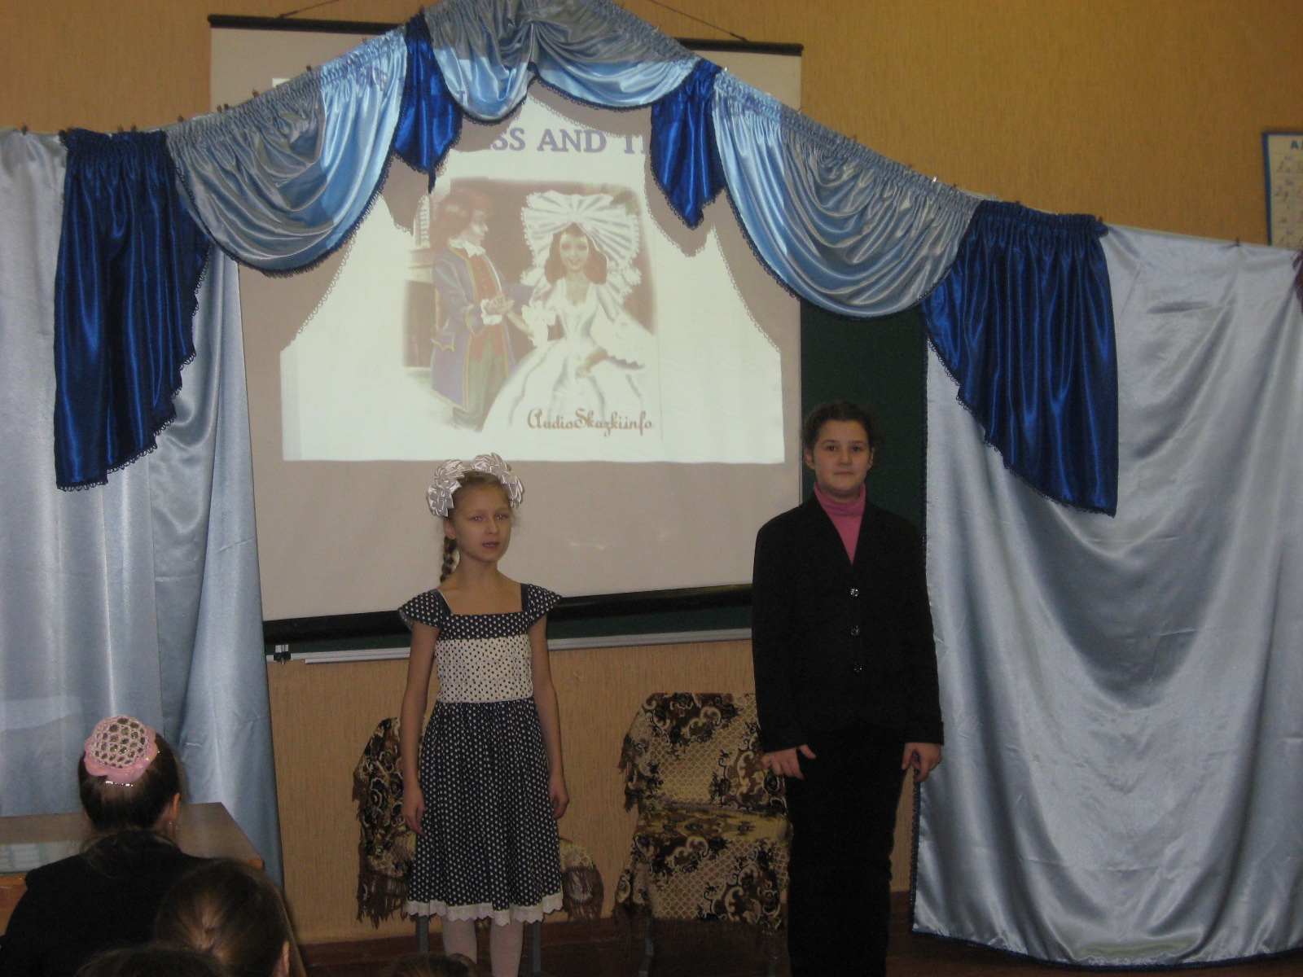
1 pupil
Dear pupils, teachers and guests! We begin our English party!
2 pupil
Today we are going to show our results of English language learning.
1 pupil
We have prepared a performance of a beautiful tale “The princess and the pea”

Part 1
The author
Once upon a time there was a prince. The prince wanted a wife. He wanted to marry a princess. So the prince traveled around the world.
Prince
I met a lot of beautiful girls, but they weren’t princesses.
(Two girls are coming)

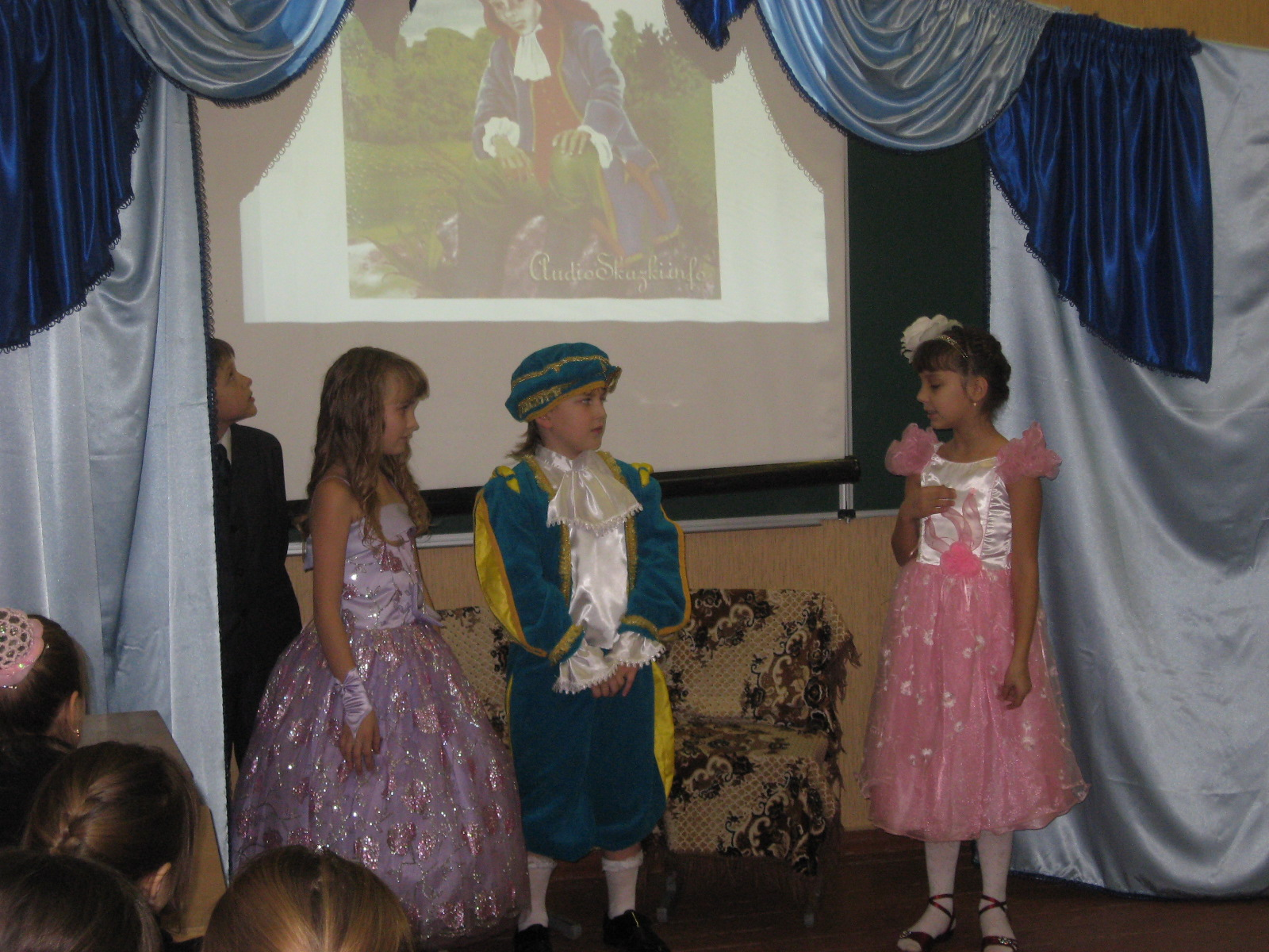
Sorry, are you princesses?
The first girl
Yes, I’m a princess. I’m from a royal family.
The second girl
No, I’m a princess. I’m from a royal family, too.
Prince
I don’t believe you. Sorry. You are too short to be a princess. And you are too tall
Prince
Thank you, good –bye! I must come back home, I am very tired.

Part 2
The author.
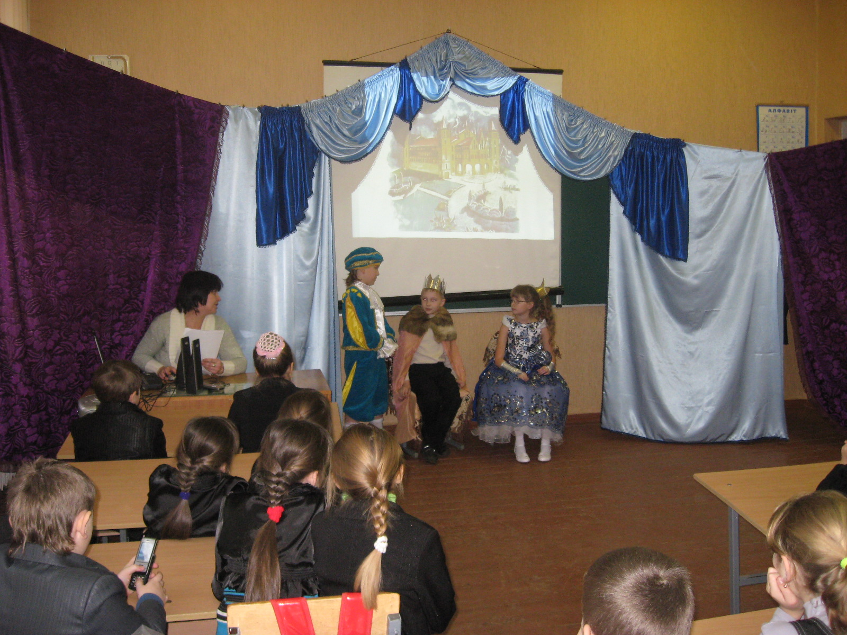
Finally, the prince went back home. He went back to his palace. The prince was very sad
Prince
Good evening, Father King. Good evening, Mother Queen.
Queen
How are you, our dear son?
King
Why are you so sad, Prince
Prince
I am very, very tired. I can’t find a princess.
King
It’s a pity! We are very sad, too!

Part 3
The author
The next evening there was a terrible storm. The sky was black and it rained and rained. It was a terrible storm.
(Sounds of storm and rain.)
(There is a knock at the palace door).
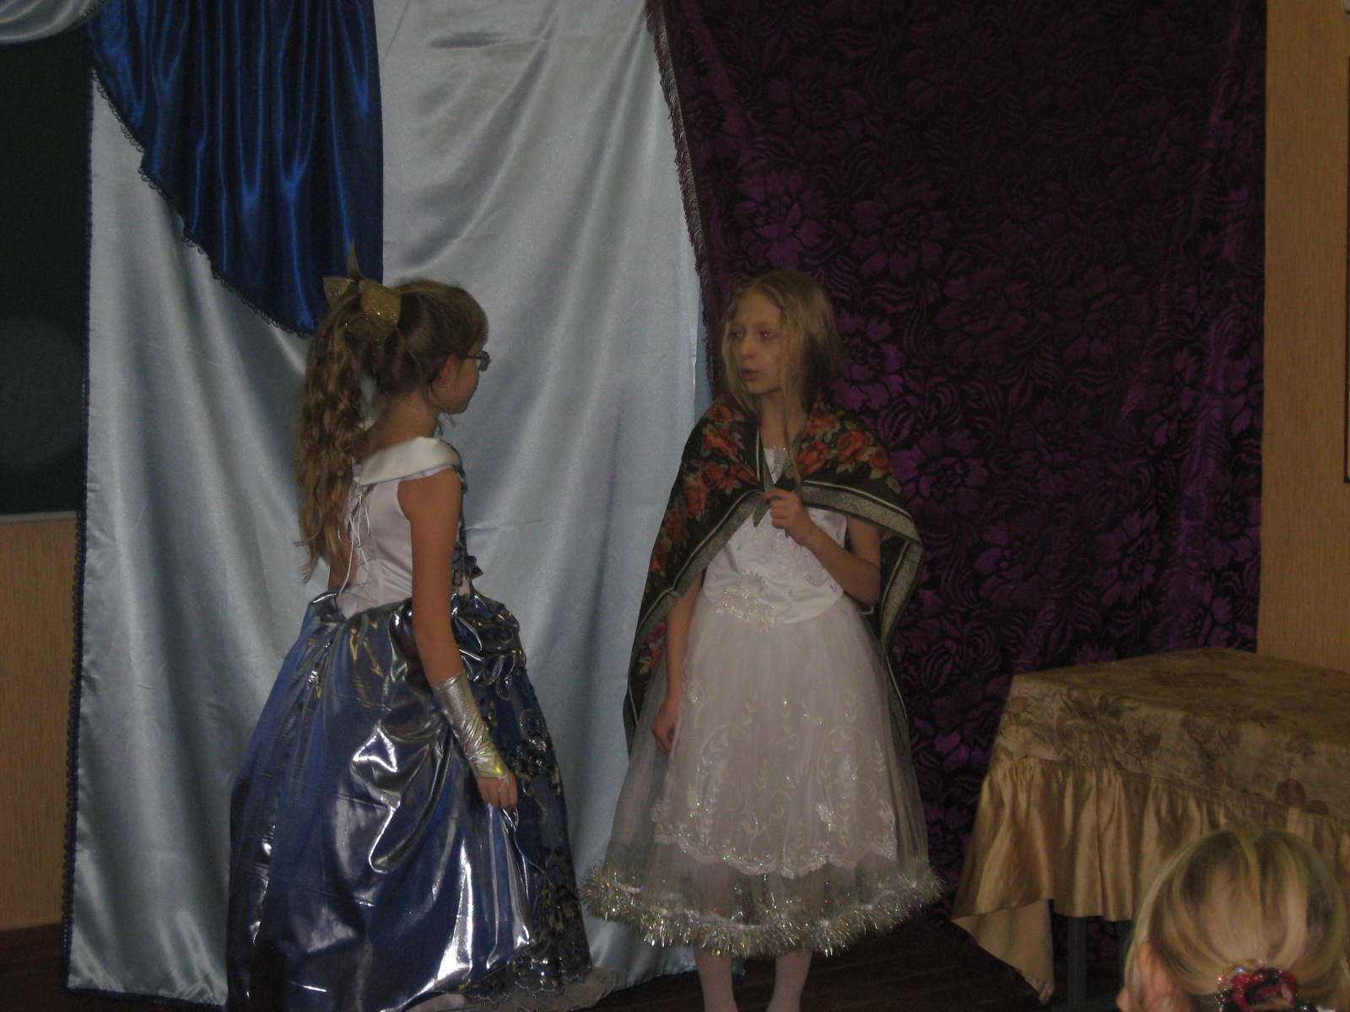
Servant (opened the door)
What are you doing in such a terrible night outside in the rain? Your hair is so wet. It is very cold. But who are you?
Princess
I’m a princess. My clothes are so wet, I’m cold. Can I stay here for one day?
Servant
I’m a servant. I must tell the Queen about you. One second. Wait, please.

Part 4
Queen
Good evening. I am a queen. And what are you doing here?
Princess
I’m a princess. My clothes are so wet, I’m cold. Can I stay here for one day?
Queen
Well, I don’t believe but …you can. You can stay with us tonight.

Servant! Servant! Where are you?

A girl is staying with us tonight. Make a bed for her. Put 20 mattresses on the bed.
(I’m going to put this pea under the mattresses.) Dear girl! Your bed is ready. Sleep well.
Princess
Oh! Thank you, your majesty! You are so kind with me. Good night!

Part 5
The author.
The next morning the queen went into the princess’s bedroom.
Queen
How did you sleep?
The Princess
I slept badly. There was something in the bed. I don’t know what it was. Perhaps it was a stone.
King
The girl is real princess! Hooray!
Queen
Yes, you are right. I believe her now. A real princess can’t sleep when there’s a pea under twenty mattresses.
King
Prince, Prince! Our son, where are you?
Prince
I am here! Good morning, your majesty!
Queen
Now you can marry the princess. This girl is a real princess. She can’t sleep when there’s a pea under twenty mattresses.
Prince
Be my wife. Do you agree?
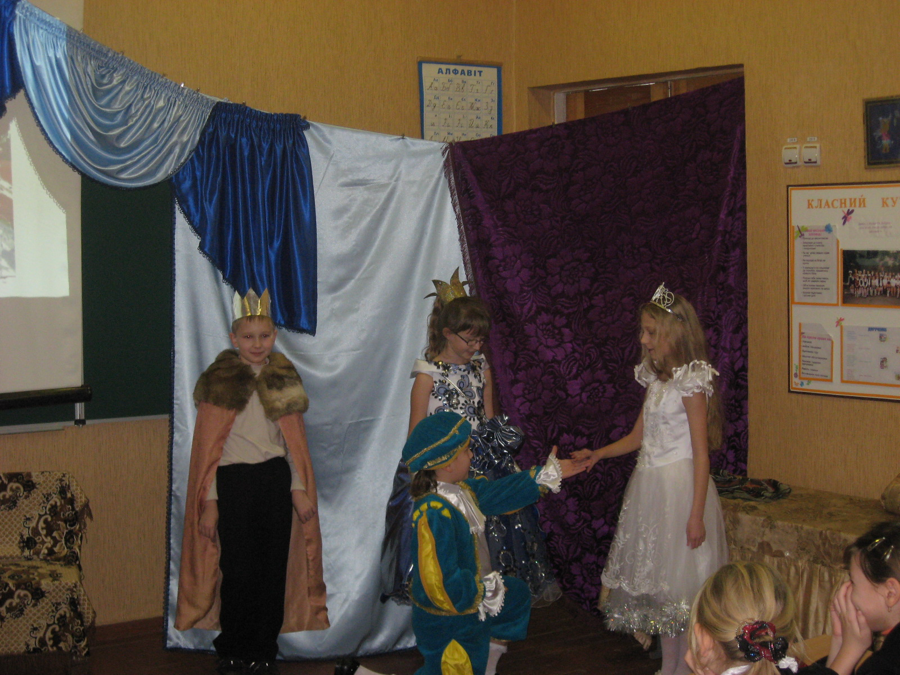
The Princess
Yes, I do.
King
Hooray! Our son will marry a princess!
Queen
But first you must take the pea to the royal museum.

The end

